**Restful Web Client Auto Marking Program Guideline**

**Things to do for Restful Web Client**

1. REST stands for Representational State Transfer. It is a software architecture style that relies on a stateless communications protocol, most commonly, HTTP.
2. You have to send request message to Web server in order to get, created or delete web resource(JSON data structure)
3. Your basic REST HTTP requests are: POST, GET, and DELETE.

**List of grading items**

1. GET : Sending a GET request would get Device information from server

Mission 1) Ex: http://<server ip>:<port>/onos/v1/devices

1. POST : Sending a POST request to add Device and a Flow.

Mission 2) Ex: http://<server ip>:<port>/onos/v1/devices/post

Mission 3) Ex: http://<server ip>:<port>/onos/v1/flows/post

1. DELETE : Sending a DELETE request to delete the device

Mission 4) Ex: http://<server ip>:<port>/onos/v1/devices/delete

**How to test?**

* + 1. 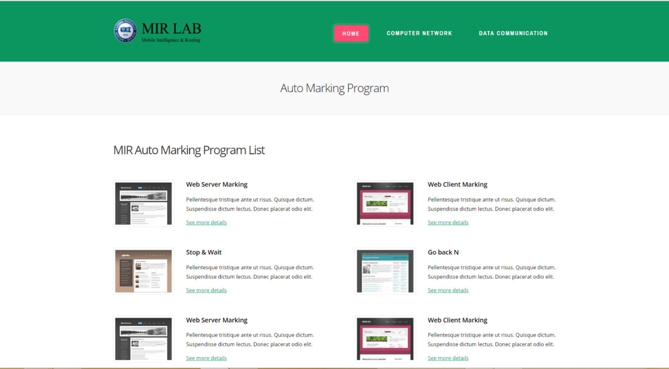Approach *http://166.104.143.225:9998/index.html#* through your web browser (Internet Explorer, Chrome, Firefox and etc.), click **DATA COMMUNICATION**
    2. 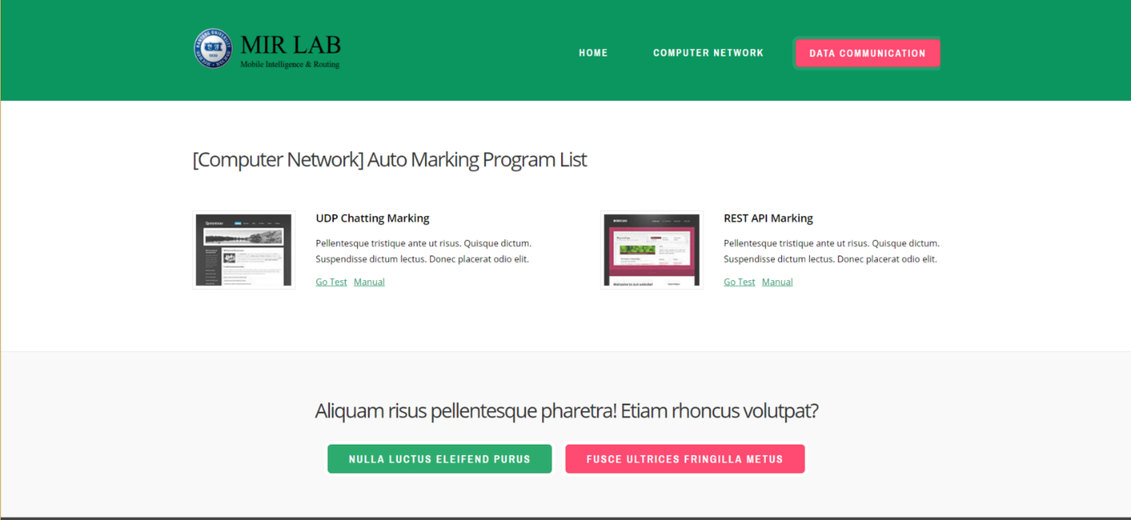REST API Marking-> Go Test
    3. Input your name, student number and client IP.->Submit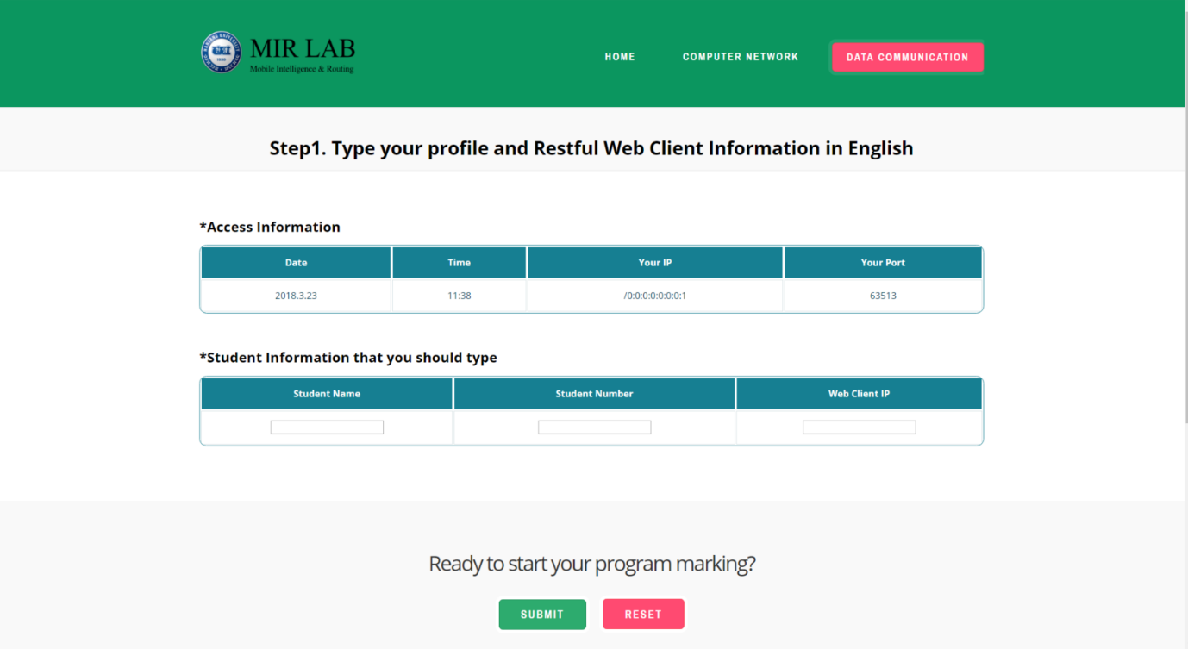
    4. You can see the port you need to connect with server and several missions to test you r restful web client

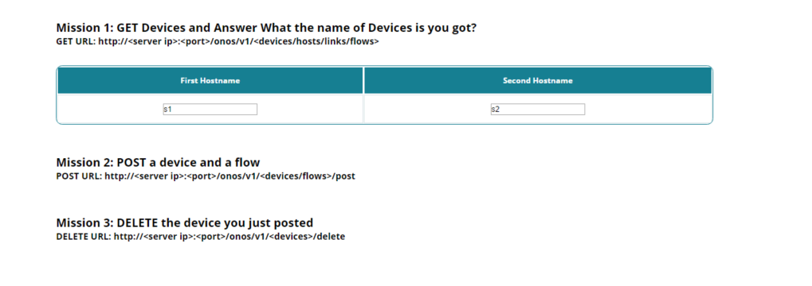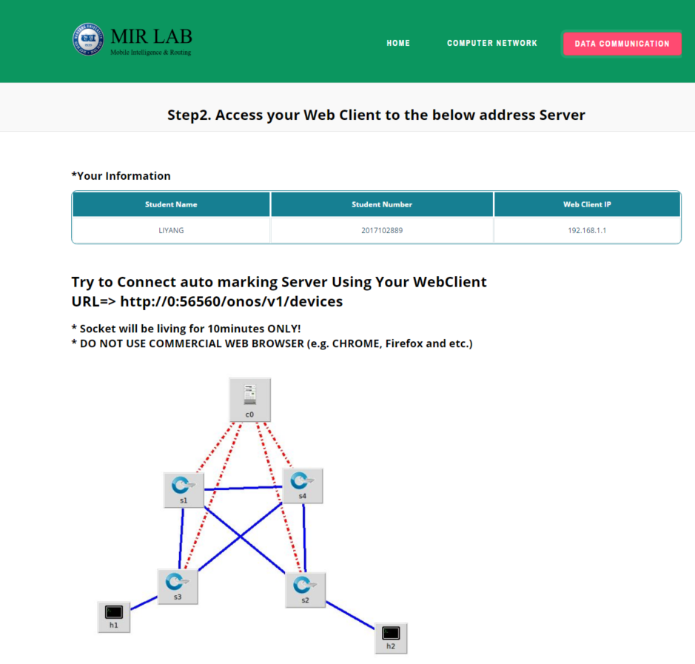

* + 1. 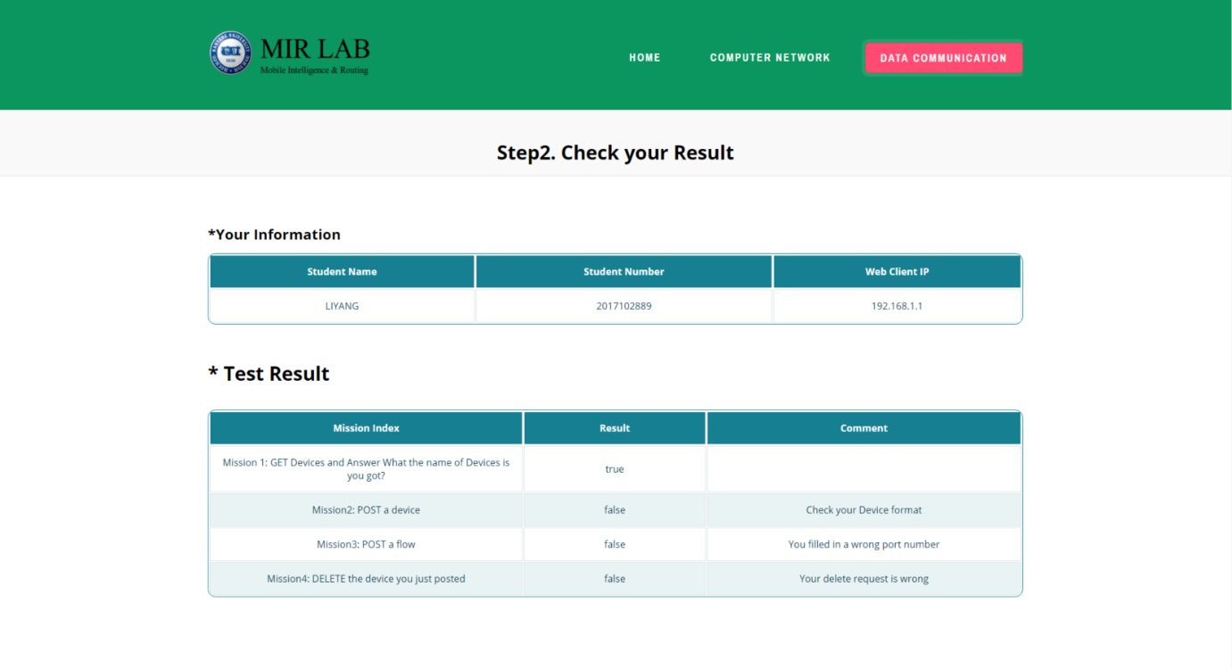Result Page